TWAHIRAH KIDS JUNIOR SCHOOL- BUSULA
P.5 END OF TERM I INTERNAL EXAMINATIONS – 2024

Integrated Science

Name: ____________________________________________________________________

Section A

- Give one use of feathers to a bird.
______________________________________________________________________
- Why is it important to wash a toothbrush after use?
______________________________________________________________________
3. State the cause kwashiorkor.
_____________________________________________________________________
Study the diagram and answer questions 4 and 5.

4. Name the organ shown in the diagram.
______________________________________________________________________
5. Mention the function of the organ above in our bodies.
______________________________________________________________________
6. Giveone way of controlling mosquitoes at the larva stage.
______________________________________________________________________
7. Which gas does a germinating seed need?
______________________________________________________________________
8. Mention one animal that poisons people when it is defending itself.
_____________________________________________________________________
- Why is the use of polythene bags as toilets discouraged?
___________________________________________________________________
- How are gills of a fish similar to spiracles of an insect?
______________________________________________________________________
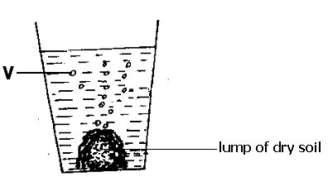Study the experiment below and answer question 10 and 11.

10. Name part marked V.
______________________________________________________________________
11. What does the experiment prove about soil?
______________________________________________________________________
12. State one way a family can promote good health care among its members.
______________________________________________________________________
13. Mention one way HIV is spread among people.
______________________________________________________________________
14. What are transparent objects?
______________________________________________________________________
15. In which part of the alimentary canal of a bird is food crushed into smaller particles?
______________________________________________________________________
16. What happens to ice when it is placed in a hot saucepan?
______________________________________________________________________
17. Which form of energy enables us to see?
_____________________________________________________________________
18. In which facility are chicks below two weeks kept?
______________________________________________________________________
19. State one way of promoting the cleanliness of our bodies.
______________________________________________________________________
- State one danger of living in a dirty environment.
______________________________________________________________________
- Name one exotic breed of rabbits.
______________________________________________________________________
- Give one way of controlling rats in our homes.
______________________________________________________________________
- What is a weed?
______________________________________________________________________
Below is a germinating seed. Use it to answer questions 24 and 25.

- What type germination does the above seed undergo?
______________________________________________________________________
- Name the root system the seedling will develop after germination?
______________________________________________________________________
- Why are people encourage to take children under five years of age for immunization?
______________________________________________________________________
- Give one practice that can improve food production in villages.
______________________________________________________________________
- What is pollination?
______________________________________________________________________
- Name one item used for the disposal of waste materials in a home.
______________________________________________________________________
- Name the parasite commonly found on bodies of dirty people.
______________________________________________________________________
- How do animals benefit from plants during photosynthesis?
______________________________________________________________________
- Give one example of a vegetable crop.
______________________________________________________________________

Given the following list: housefly, stone, rabbit and plant.
- Which item in the above list is different from others?
______________________________________________________________________
- Give a reason for your answer in (33) above.
______________________________________________________________________
- How is a tsetse fly dangerous to our health?
______________________________________________________________________
- What injury is caused by hot milk?
______________________________________________________________________
- State one danger of eating sweets and cakes regularly.
______________________________________________________________________
- Give one importance of leaves to a plant.
______________________________________________________________________
- What is a pen in poultry keeping?
______________________________________________________________________
40. Give one importance of a school garden.
______________________________________________________________________

SECTION B
41(a) What is poultry?
______________________________________________________________________
(b) What type of chicken do farmers keep for the following purpose?
(i) producing eggs and meat
______________________________________________________________________
(ii) producing eggs
______________________________________________________________________
(c) Mention one exotic breed of chicken.
______________________________________________________________________
42(a) Give one use of water in a community.
______________________________________________________________________
(b) State two ways water sources can be contaminated by people.
(i) ______________________________________________________________________
(ii) ______________________________________________________________________
(c) Mention one way water can be made safe for drinking.
______________________________________________________________________
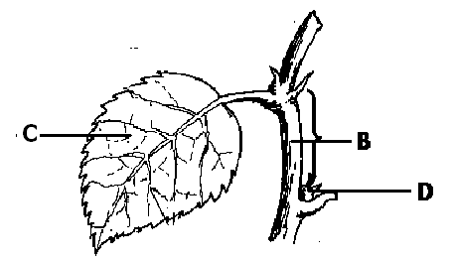43. Below is a diagram of a part of a plant. Use it to answer the questions that follow.

(a) Name part Marked B.
______________________________________________________________________
(b) How is part B useful to a plant.
______________________________________________________________________
(c) Why is it important for part C to remain green?
______________________________________________________________________
(d) Mention one part of a plant that can develop from part D.
______________________________________________________________________
44(a) Which type of worms can be prevented through the following:
(i) wearing shoes:______________________________________________________
(ii) eating well cooked meat:_______________________________________________
(b) State one way worms affect human health.
______________________________________________________________________
(c) Apart from wearing shoes and cooking meat properly, give one other way of preventing worm infestation.
______________________________________________________________________
45. Study the diagram below and answer the questions that follow.

(a) What type of injury is shown above?
______________________________________________________________________
(b) Mention one possible cause of the above injury.
______________________________________________________________________
(c) How is the structure marked B important while giving first aid to a casualty affected with such an injury?
______________________________________________________________________
(d) State one way the above injury can be prevented.
______________________________________________________________________
46(a) What is the main source of light energy?
____________________________________________________________________
(b) Name the body organ that responds to sound energy.
____________________________________________________________________
(c) How is electricity dangerous to the users?
____________________________________________________________________
(d) State one way wind is useful to a crop farmer.
____________________________________________________________________
47(a) What is soil erosion?
______________________________________________________________________
(b) Name the layer of soil mostly affected by erosion.
______________________________________________________________________
(c) Mention two ways of controlling soil erosion.
(i) ______________________________________________________________________
(ii) ______________________________________________________________________
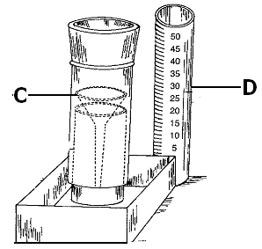48. Study the diagram and answer the questions about it.

(a) Name the instrument shown in the above diagram.
____________________________________________________________________
(b) What element of weather is measured by the above instrument?
:____________________________________________________________________
(c) Name part C of the instrument.
______________________________________________________________________
(d) How is part D important when using the instrument?
______________________________________________________________________
49(a) What is mulching?
______________________________________________________________________
(b) State one importance of crop rotation in crop growing.
_____________________________________________________________________
(c) Mention one way farmers can ensure proper spacing of crops in the garden.
______________________________________________________________________
(d) Give one use of a wheelbarrow on a crop farm.
_____________________________________________________________________
50(a) Why to farmers harvest cereal crops in the dry season?
______________________________________________________________________
(b) State one method farmers use to preserve harvested crops.
______________________________________________________________________
(c) Name one storage facility for cereal crops.
______________________________________________________________________
(d) Name one pest that destroys crops under storage.
______________________________________________________________________
51. The diagram shows a human tooth. Use it to answer the questions that follow.

(a) Name the type of tooth shown in the diagram.
______________________________________________________________________
(b) How is the tooth above important during food digestion?
______________________________________________________________________
(c) What mineral is necessary for proper development of part marked G?
______________________________________________________________________
(d) Name part marked Y?
______________________________________________________________________
52(a) Mention one advantage of using free- range system of poultry keeping.
______________________________________________________________________
(b) How is battery cage system a disadvantage?
______________________________________________________________________
(c) State one cause of egg eating in layers.
______________________________________________________________________
(d) Suggest one way of controlling vices in poultry.
____________________________________________________________________
53(a) State one cause of dehydration in human bodies.
______________________________________________________________________
(b) Give one effect of dehydration of a human body.
______________________________________________________________________
(c) Name any two things needed in making ORS.
(i) ______________________________________________________________________
(ii) ______________________________________________________________________
54. The diagram below is of an egg. Use it to answer the questions that follow.

(a) Why wouldn’t it be necessary to incubate an unfertilized egg?
______________________________________________________________________
(b) Name part marked T.
______________________________________________________________________
(c) How is part X important in the egg?
______________________________________________________________________
(d) Give one thing that a fertilized egg needs to hatch into a chick.
______________________________________________________________________
55(a) Give one example of a mineral salt needed in a human body.
______________________________________________________________________
(b) Mention one importance of vitamins in our bodies.
______________________________________________________________________
(c) Why do children under five years need a lot of proteins?
______________________________________________________________________
(d) What class of food gives our bodies energy?
______________________________________________________________________

